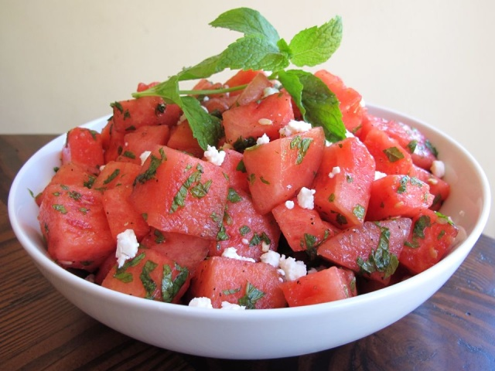

Watermelon Feta Salad with Mint

Ingredients
- 1 7-8 lb. seedless watermelon, chilled
- 1/2 cup extra virgin olive oil
- 3 limes, juiced
- 1 1/2 tsp salt
- 3/4 tsp black pepper
- 1 cup fresh chopped mint leaves
- 1 1/2 cups crumbled feta cheese (goat or sheep milk feta is best)
Total Time: 20 Minutes Servings: 8 servings
- Note: This salad is best made just prior to serving. Prepare one hour or less before your meal.
- Cut rind from the watermelon, then chop the fruit into 1 inch chunks. Place chunks in a colander to drain as your chop.
- In a small bowl, whisk together olive oil, fresh lime juice, salt, and black pepper to create a dressing.
- Place watermelon in a large salad bowl. Pour dressing and chopped mint over the watermelon and toss gently to coat.
- Pour the crumbled feta into the salad bowl and stir gently to integrate the cheese into the salad. Serve.

