Watermelon radish chips
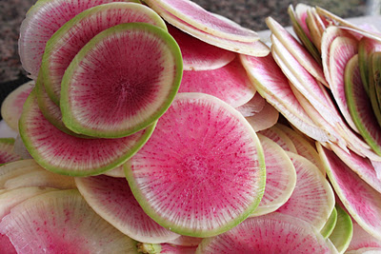

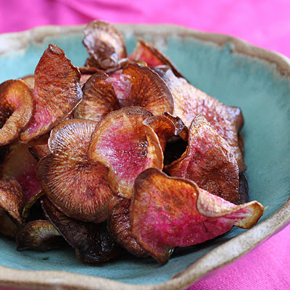

5 ways to eat a Watermelon Radishes
- Use watermelon radishes raw, sliced in thin disks with dip
- Quarter them, toss in olive oil, and roast in the oven with carrots or beets
- Slice & sauté them in butter and salt by themselves or with shallots
- Make a watermelon radish chickpea salad on our website. http://www.mountainmeadowsfarmtn.com/recipes.html
- Watermelon radish chips
Watermelon radish chips
Thin slices of crisp radish deep-fried, then sprinkled with sea salt:

Ingredients
- 4-6 cups grapeseed or canola oil, for deep frying
- 1 pound watermelon radishes, scrubbed well (do not peel)
- sea salt
- cumin or other seasoning (optional)
Instructions
In a medium saucepan, heat the oil to 325 degrees (a deep-fry thermometer clipped to the side of the pan is a helpful tool). You want the oil to be a few inches deep, with plenty of room for things to bubble up without spilling over as you drop in the chips. While the oil is heating, slice the watermelon radishes thinly. If your knife skills are good enough to do this by hand, congratulations. Mine are not, so I use a hand-held mandolin. Line a plate with several layers of paper towel. Test the temperature of the oil by adding one slice of radish to the pot. It should bubble aggressively and be golden brown in less than a minute. If this is the case, remove the test chip and flip it onto the paper towel to drain. Add a handful of chips, making sure to separate them as they go into the pot so they don't stick together. Turn them over as the edges brown, then take them out and drain them on the paper towel. Continue in a similar fashion until all the chips are used up. Sprinkle them with a tiny bit of salt every few batches, but be careful not to overdo it. You want to salt them when they're hot. Serve immediately.

Prep time: 10 mins Cook time: 20 mins Total time: 30 mins Yield: 4 servings

