Chickpea Watermelon Radish Salad
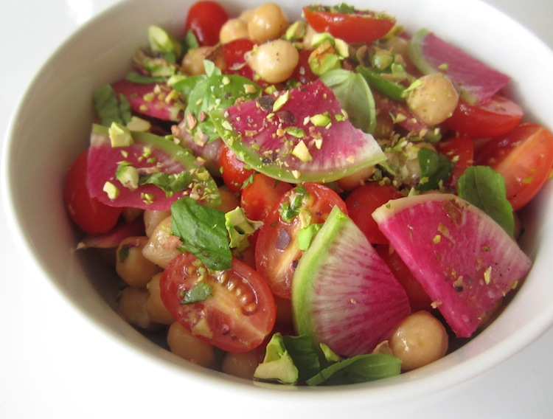
Chickpea Watermelon Radish Salad
2 cups chickpeas, cooked
12 or so cherry tomatoes, sliced
1/2 cup watermelon radishes, sliced
1/4 cup pistachios, chopped
1 tablespoon basil, torn
1 tablespoon lemon juice
1-2 teaspoons honey
2 tablespoons extra virgin olive oil
salt and pepper, to taste
Chunks of avocado (makes a nice addition if you like)

1. In a medium bowl, mix the chickpeas, grape tomatoes, watermelon radishes, pistachios, and basil. Stir gently.
2. In a small bowl, combine the lemon juice, honey, olive oil, salt, and pepper. Whisk and then add to the chickpea mixture. Garnish with watermelon radish slices and chopped pistachios.

